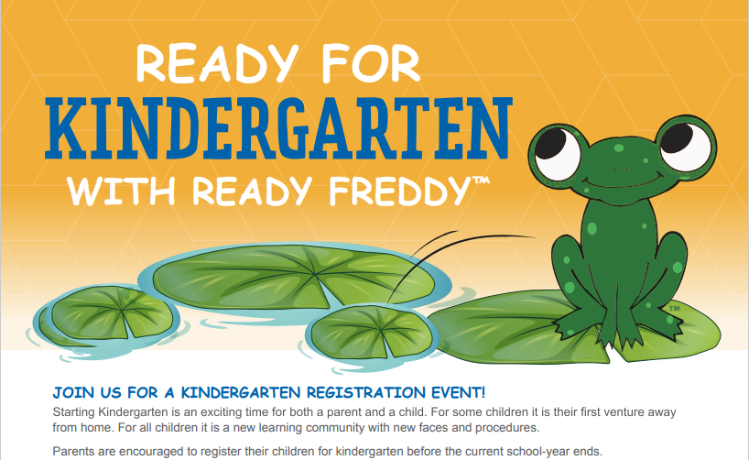

We would like to welcome you to Clark Elementary as you begin the journey of your child starting Kindergarten. Please join us for an in person informational session and tour.

**School:** Clark Elementary

**Date:** 04/16/24

**Location:** Clark Elementary

**Time:** 5:00-6:00

**How to Register:** Use the link below to register.

**Use QR code or Link to Register:**

<https://www.signupgenius.com/go/10C0C4AAFA82EA5F9CE9-kindergarten2>

